GCSA EMPLOYEE TRAINING WORKBOOK
Water Quality and Urban Stormwater Pollution Basics
Prepared by Richard Smith for INCOG, June 2006
The following information contains PowerPoint slides with associated discussion of each topic. This is the first of 5 Workbooks covering INCOG’s updated Stormwater 101 Education and Outreach for its GCSA Members. The material will benefit not only new staff who may be unfamiliar with stormwater permit requirements, but for city management and elected officials.
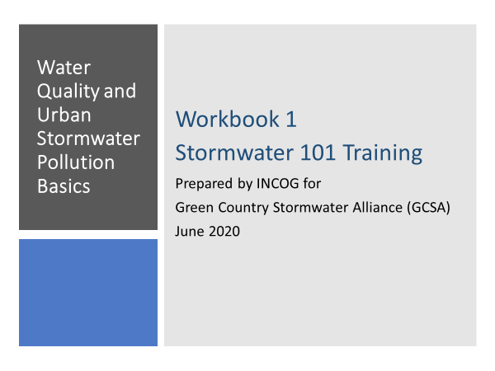
SLIDE 1: Welcome to the first of 5 Workbooks addressing the basics of Stormwater Permitting in Oklahoma, including your city or county requirements under your permit.
This Workbook series is produced by INCOG for its Green Country Stormwater Alliance (GCSA) Members.
Many GCSA Member staff are new to their Stormwater Manager jobs. A recent Member Survey found strong interest in having training on Stormwater 101.
With the COVID-19 pandemic preventing workshops at this time, INCOG will be preparing Training Workbooks on topics of most importance to its GCSA Members.
This first Workbook will provide a general background on Water Quality Standards and the need for stormwater permitting.
Subsequent Workbooks in this Stormwater 101 training series will give greater detail on the OKR04 stormwater general permit.
SLIDE 2: Workshops are great venues for meeting face-to-face; they generate valuable feedback when audience questions can be answered and discussed.
However, for a variety of logistical reasons, GCSA Workshop meetings are typically only attended by a small portion of our 110+ members.
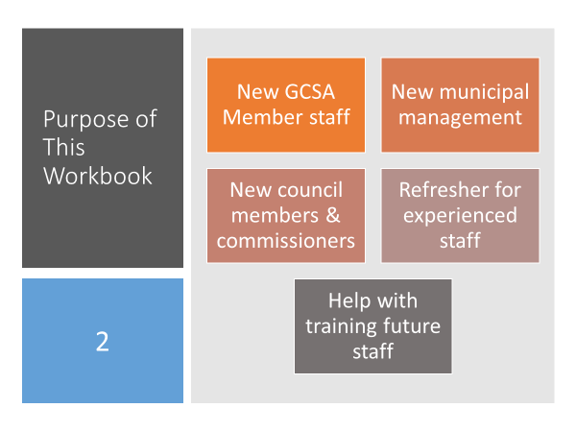
Employee Training Workbooks can be used by a much larger GCSA audience in their workplace without having to travel, and at a time convenient to each person.
Who is our Target Audience? Primarily the newest staff of our GCSA Members who need to have a thorough background in water quality and stormwater permitting.
However, it is hard to reach City Management and Elected Officials. These Decision-Makers are often asked to approve documents and budgets for mandatory Stormwater Permit programs.
They need to have a good understanding of urban water quality protection and the stormwater permit’s many requirements.
These Workbooks can help as Refresher Courses for experienced staff, and they can be used to help train new staff that may be hired in the future.
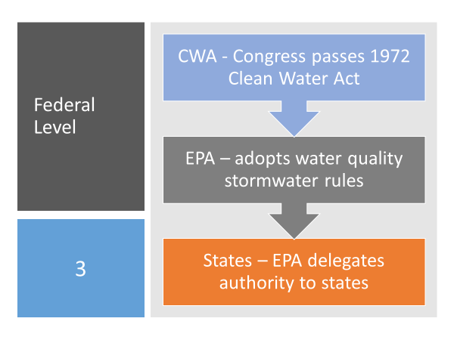
SLIDE 3: In the 1970s, urban areas were identified by the US Environmental Protection Agency (EPA) as major sources of water quality pollution.
EPA’s National Urban Runoff Program (NURP) produced a bookshelf of technical documents describing in detail the types and sources of urban pollutants that were widespread throughout the country.
Congress passed the Clean Water Act (CWA) in 1972, and there have been many amendments since then.
The CWA lays out a variety of obligations that pollutant dischargers must meet; one of those programs addresses urban stormwater pollution.
The Federal water quality permitting process is “Top-Down”. Congress passes a law and directs EPA to develop regulations that address all requirements specified in the Law.
For stormwater, EPA elected, in turn, to delegate further down, authorizing qualifying states to assume primary responsibility over the federal stormwater permit program.
The Oklahoma Department of Environmental Quality (DEQ) received EPA delegation as a stormwater “Permitting Authority” (PA) in 1997. The DEQ is now the lead agency in Oklahoma over stormwater permit issuance and compliance.
Oklahoma’s DEQ, in turn, requires that designated cities and counties obtain a stormwater permit and enforce locally the CWA’s pollution reduction mandates.
Thus the Top-Down delegation of: Federal Law to Federal Agency to State Agency to Local Municipality.
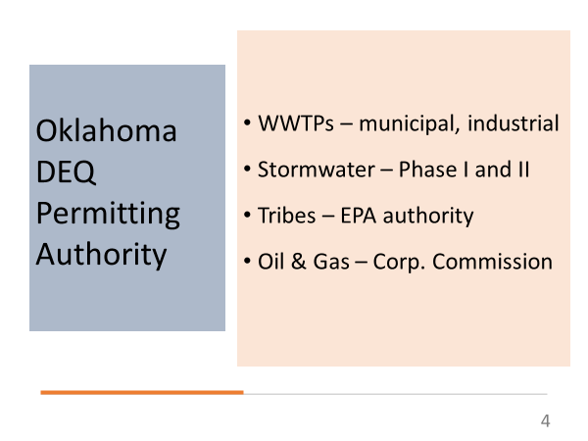
SLIDE 4: Stormwater permitting is complicated. The EPA and State rules allow individual or general permit compliance. Permits cover many types of activities associated with municipal operations, construction sites and industrial activities.
DEQ has stormwater Permitting Authority over municipal, construction and industrial activities that are not affiliated with Tribes or Oil & Gas.
GCSA Members and INCOG’s GCSA technical support cover municipal activities.
All stormwater permits have a common goal: protection of water quality. The measure of protection is defined in Oklahoma’s Water Quality Standards (WQS).
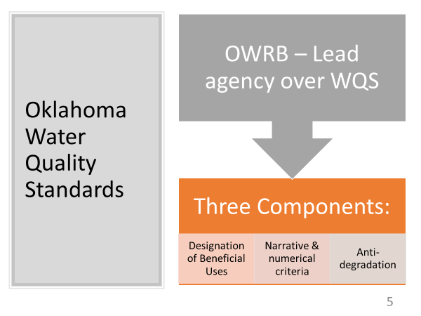
SLIDE 5: The Oklahoma Water Resources Board (OWRB) has been delegated by the Oklahoma State Legislature responsibility for development of the WQS.
Chapter 45 of the WQS establishes numerical and narrative criteria for many types of pollutants, such as metals, bacteria and toxic compounds.
Chapter 46 of the WQS define the analytical procedures for determining exceedances of the standards that indicate water quality problems.
There are three cornerstones in the Oklahoma WQS:
- Designation of Beneficial Uses (BUs),
- Setting narrative and numerical criteria to protect BUs, and
- Setting Antidegradation requirements.
Beneficial Uses are categories of the ways in which “Waters of the State” are used. These include fisheries, water supply and recreation.
Each Beneficial Use has its assigned WQS for protection. If the Chapter 45 criteria are exceeded using the assessment methods in Chapter 46, then the waterbody “has been determined to not be attaining one or more of its Beneficial Uses”.
Nonattainment of Beneficial Uses leads to a 303(d) List impairment determination.
Antidegradation is a concept in the WQS that water quality in any waterbody cannot be worsened (“degraded”).
SLIDE 6: Beneficial Uses (BUs) are categories of how Waters of the State are used. These are:
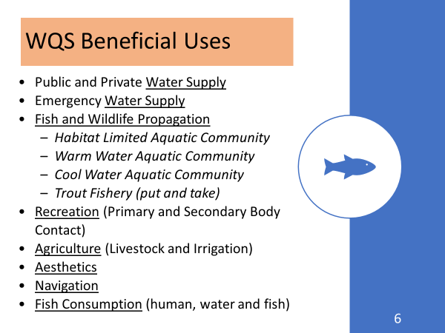
- Water Supply (both public & private, and emergency),
- Fish and Wildlife Propagation (with subcategories for “Aquatic Communities” such as for habitat limited, warm water and cool water, and a special subcategory for “put and take” trout fishery,
- Recreation (for both primary and secondary body contact),
- Agriculture (for both livestock and irrigation),
- Aesthetics (that is, the physical appearance of the water),
- Navigation (the adequacy of water flow and volume), and
- Fish Consumption (by humans, including consuming fish flesh and water).
Each Beneficial Use has its own set of WQS criteria assigned to protect it.
Every waterbody in Oklahoma, called a “Waters of the State”, has its own combination of Beneficial Uses assigned to it in the WQS. For those waterbodies not specifically listed in Appendix A of Chapter 45 of the WQS, there is a default set of Beneficial Uses assigned. These are:
- Agriculture Irrigation,
- Aesthetics,
- Warm Water Aquatic Community, and
- Primary Body Contact Recreation.
Changing Appendix A Beneficial Use designations can only be done by a special study, called a Use Attainability Analysis.
SLIDE 7: In addition to the Chapter 45 numerical criteria to protect the Fish and Wildlife Propagation Beneficial Use, Chapter 46 also has an extra provision to assess attainment based upon Biological Criteria (“biocriteria”).
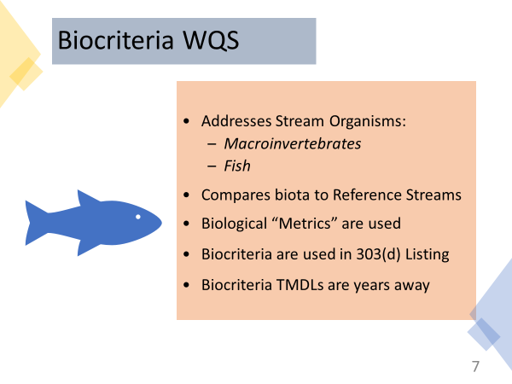
Special field studies of collections of fish and macroinvertebrates in streams are used for making biocriteria assessments.
The quality of biological “communities” is assessed using statistical “metrics” which compare the biological communities to other streams of similar size (called “reference streams”).
If the metrics of the sampled stream fall below the minimum when compared to metrics for comparable reference streams, then the stream is considered impaired.
Further studies must be conducted to determine the causes of impairment. There may even be a combination of factors.
Oklahoma has many dozens of streams now listed as 303(d) impaired for either fish biology, macroinvertebrate biology, or both.
While TMDLs for these biological impaired streams are years away, Oklahoma has begun to develop “tools” for determining the causes of biological impairment that will lead to TMDL development.
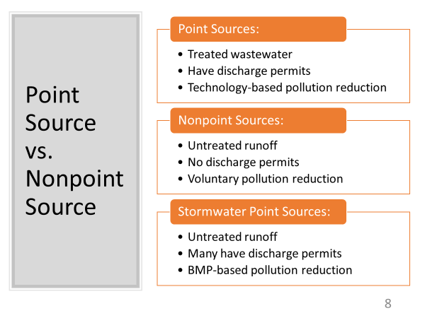
SLIDE 8: There are two ways pollution can be discharged to a waterway: either through a pipe or from runoff over the surface of the ground. These are called “Point Source” and “Nonpoint Source” discharges.
Pipe discharges are often the last step in a wastewater treatment process, such as a municipal Publicly Owned Treatment Works (POTW), also called a Wastewater Treatment Plant (WWTP).
Both cities and industries use WWTPs to treat raw wastewater before discharging the “Effluent” via a pipe to a local stream or river.
DEQ issues point source WWTP discharge permits under their Oklahoma Pollutant Discharge Elimination System (OPDES) permit program.
Traditional Nonpoint Sources have no wastewater treatment. Runoff from a variety of land uses flows into gullies and ditches until it reaches receiving streams as untreated flows.
There are no permits for traditional Nonpoint Source discharges, nor any treatment before entering receiving streams.
In urban areas, most untreated surface runoff flows into stormwater collection systems. Like traditional Nonpoint Sources, urban stormwater discharges receive no wastewater treatment.
EPA’s Phase I and Phase II stormwater permit programs require that designated urban areas obtain discharge permits for their stormwater.
The stormwater permit program requires implementation of Best Management Practices (BMPs) to control pollution within urban areas before it enters the stormwater collection system.
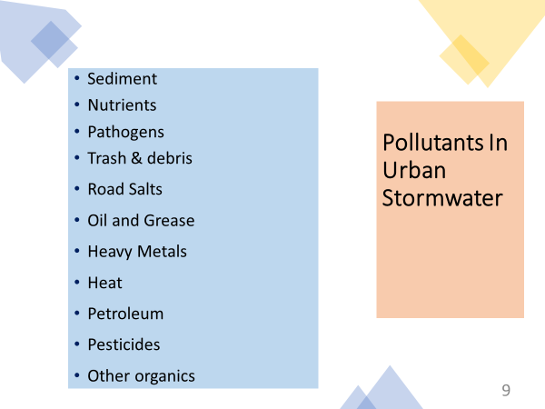
SLIDE 9: What types of pollution would you expect to be in urban stormwater runoff?
Basically any pollutant imaginable; the sources are endless, from “Illicit Discharges” from illegal dumping to runoff from parking lots, lawns and streets.
Some types of pollution come from sources that cannot be controlled by local stormwater permitted cities.
These include pollution from agricultural practices and oil and gas extraction. These sources either have exemptions under the Clean Water Act or are controlled by agencies other than DEQ’s municipal stormwater permit program.
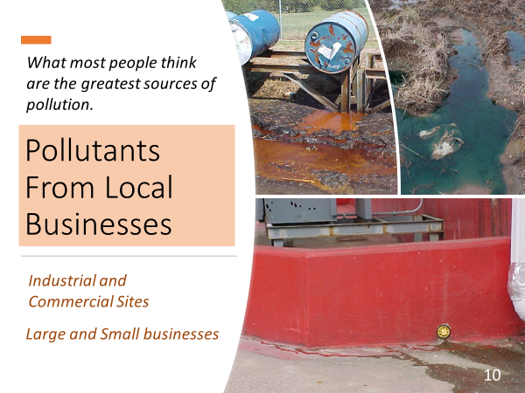
SLIDE 10: When we think of urban pollution, we usually think of industrial sites, especially those with inadequate pollution controls such as leaking tanks and discarded piles of chemical containers.
These are a problem of course, but industries and local businesses are only a few of the types of pollution sources.
Even a small business can be a greater source of pollution than a large industrial facility.
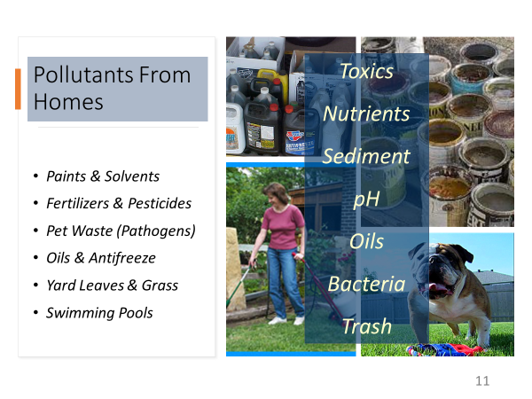
SLIDE 11: How can a residential home in a quiet neighborhood be a source of pollution?
In fact, homeowners use very toxic chemicals, sometimes inappropriately, and they often carelessly pour waste chemicals into gutters, stormdrain inlets or on the ground.
Many homeowners, frustrated with weeds or insect pests that won’t die, will over-apply chemicals in higher concentrations than recommended.
Many chemical applications are done just before rainfall which washes their expensive and toxic chemicals into the stormwater collection system.

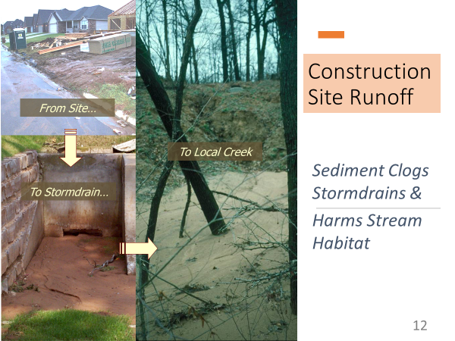
SLIDE 12: We all have seen the ugly pollution from construction sites: dirt tracked into streets by trucks and sediment washed into gutters from rainfall runoff.
Construction sites also contribute chemical pollutants in runoff, including pesticides, solvents, fuels, fertilizers, and trash.
So why is dirt a problem for receiving streams? Isn’t there dirt in streams already; isn’t dirt natural?
Of course this is true, but the problem comes when too much dirt (called sediment) gets deposited.
Masses of sediment build up in underground storm drains which reduces or stops their flow, defeating the purpose of stormwater conveyance for flood control.
In addition, excess sediment in streams buries habitat for aquatic organisms, and suspended fine sediment particles clog fish gills.
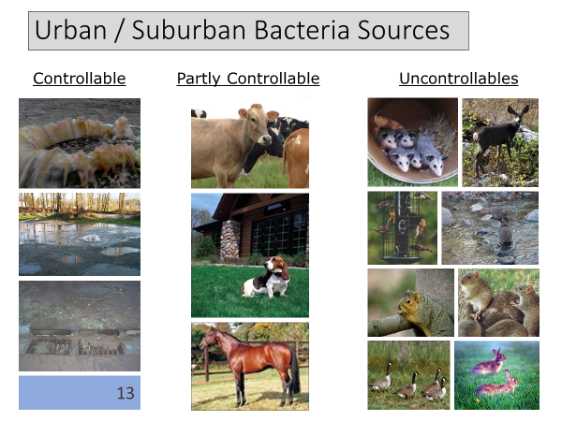
SLIDE 13: Bacteria (pathogens) are a major water quality problem in urban areas, but the issue is complicated and can frustrate stormwater permittees.
The water quality standards have numerical limits for “Indicator Organisms” (Enterococcus and E. coli). But most strains of these bacteria are not harmful to humans, they are essential.
We all have these bacteria in our digestive system. They break down food and help us to absorb essential nutrients from what we eat.
Unfortunately, these same Indicator Organisms are also inside all warm-blooded mammals, and we all expel billions of these bacteria in our waste.
The presence of E. coli or Enterococcus only indicates the possibility that other (true) pathogens might be present in the water sample.
Some bacteria sources can be controlled (e.g., sewage collection systems), some partly controlled (e.g., pets), but many sources cannot be controlled (e.g., wildlife).
Sampling for E. coli or Enterococcus cannot distinguish between these sources, so additional sampling may be needed to characterize bacteria sources.
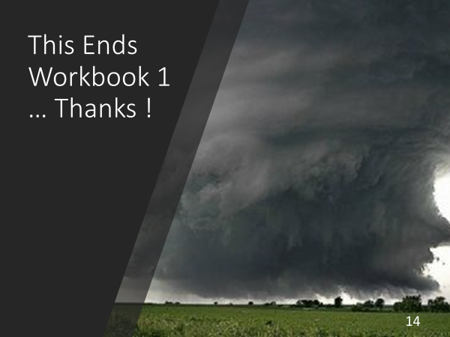
SLIDE 14: This ends the first of 5 GCSA Training Workbooks on water quality and stormwater permitting basics.
Please contact INCOG at stormwater@incog.org or (918) 579-9451 if you need additional information about this material.
The PowerPoints for these Workbooks will also be provided to GCSA Members, and videos of the PowerPoints with narration may also be produced.

